NI Switch Executive 2.0 Demo Script

Overview
This demo sets up the routings for a frequency response test of 2 UUT’s (Unit Under Test). A switching system of 2 matrices is needed to route excitation signals to 2 UUT’s and route their response signals to 3 instruments, as shown in Figure 1. You will demonstrate the features of NI Switch Executive as you create the channels, routes, route groups, and hardwires necessary to test the 2 UUT’s. This is a software only demo.

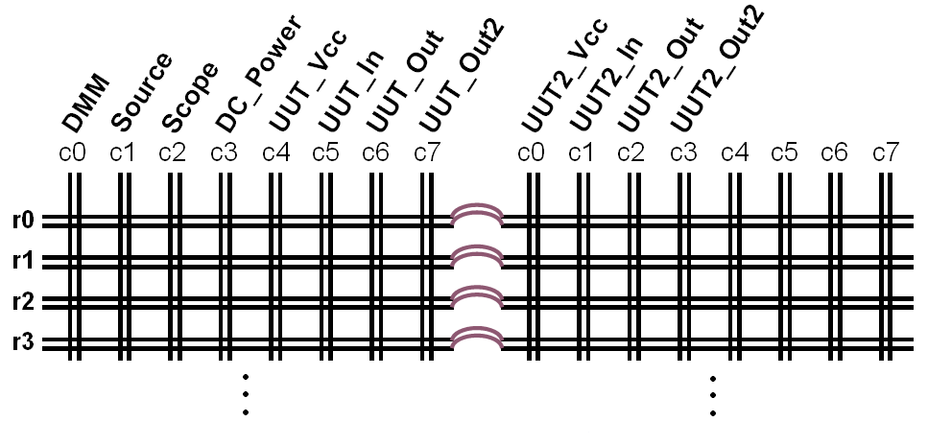
Figure 1

Required Software
NI Switch Executive 2.0
LabVIEW 7.1
NI Switch 2.2
NISwitchExecDemo.zip

Step-By-Step Instructions
1) Open Measurement & Automation Explorer and expand the Devices and Interfaces listing in the tree.

2) Right click on the Switch Executive Virtual Device listing and select Create New Switch Executive Virtual Device.

3) Change the Virtual Device Name to FrequencyResponseDemo and select Create New Configuration. Click Next. To learn more about NI Switch Executive naming conventions, see the NISE help file and search for naming conventions.

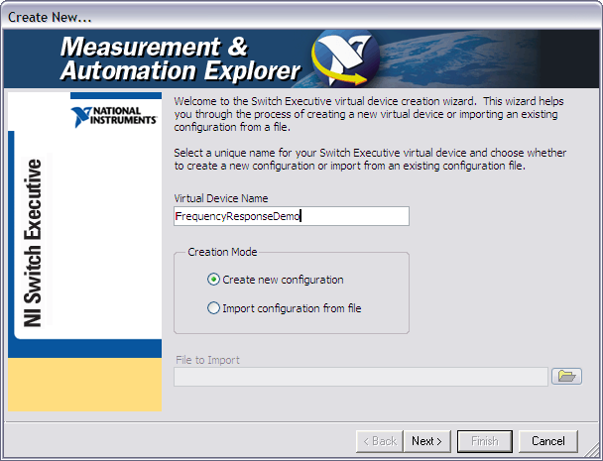

Figure 2

4) Add SampleMatrix1 and SampleMatrix2 to the Virtual Device and click Next.

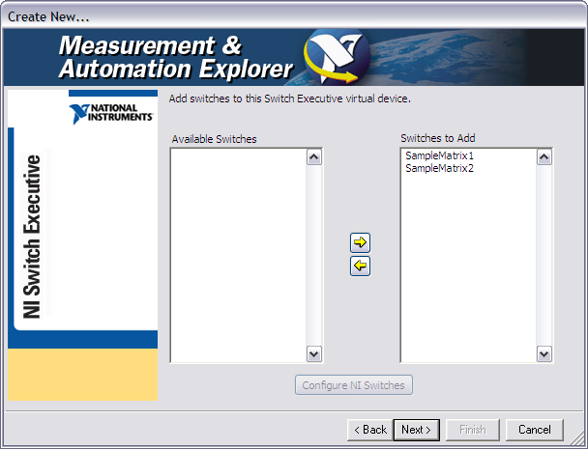

Figure 3
5) Once the 2 matrices have been added to the FrequencyResponseDemo virtual device, click Finish.

6) The newly created FrequencyResponseDemo virtual device will automatically be displayed in Measurement & Automation Explorer (MAX). Click on the Show/Hide Tree button to hide the MAX tree since we will not be using it while configuring the switches. Now that we have imported 2 matrices into a Switch Executive virtual device, we can start configuring them.

7) Make sure that the Channels/Exclusions tab is selected at the bottom of the screen. We will now start entering aliases for the channels as shown below. Aliases allow a channel to be referred to by a more descriptive name within Switch Executive (NISE) and any Application Development Environment (ADE) that uses IVI Drivers. Since we will give aliases to column channels only, we can filter out channels not starting with “c” by typing “c” in the box below the IVI Channel column.
SimpleMatrix1 |  |  | SimpleMatrix2
c0 | DMM |  | c0 | UUT2_Vcc
c1 | Source |  | c1 | UUT2_In
c2 | Scope |  | c2 | UUT2_Out
c3 | DC_Power |  | c3 | UUT2_Out2
c4 | UUT1_Vcc |  | c4
c5 | UUT1_In |  | c5
c6 | UUT1_Out |  | c6
c7 | UUT1_Out2 |  | c7

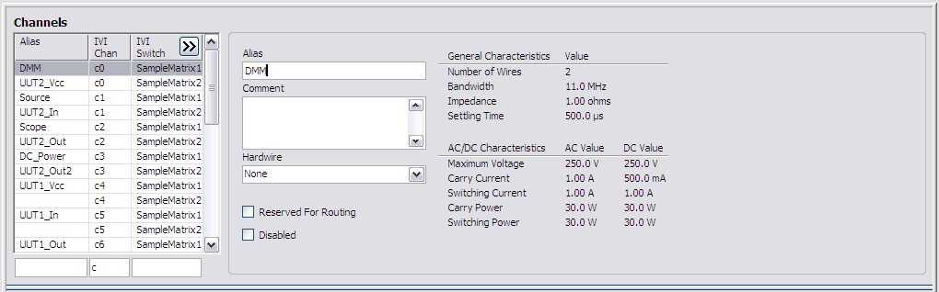

Figure 4

8) Filter channels not starting with the letter “r”. Set up all eight of the rows of both matrices as configuration channels. Select row r0 on SimpleMatrix1 and enable the checkbox beside Reserved For Routing. Do this for all of the rows on both matrices. Marking a channel as reserved for routing notifies NI Switch Executive that it can use the given channel as needed to complete a route. While marking a channel as reserved for routing allows NI Switch Executive to use the channel for completing a route, you still have ultimate control over whether or not a channel is to be used in a given route.

9) Click on the Hardwires/Buses tab and create Hardwires that connect each of the 8 rows to each other. This will tell Switch Executive what physical connections exist between the 2 matrices.
a) Filter out all channels that do not start with “r” from the Available Channels list
b) Click the Add Hardwire button.
c) Select the two channels that are to be connected, in this case row r0 on SimpleMatrix1 and r0 on SimpleMatrix2 as shown in Figure 5.
d) Do the same for all eight of the rows.

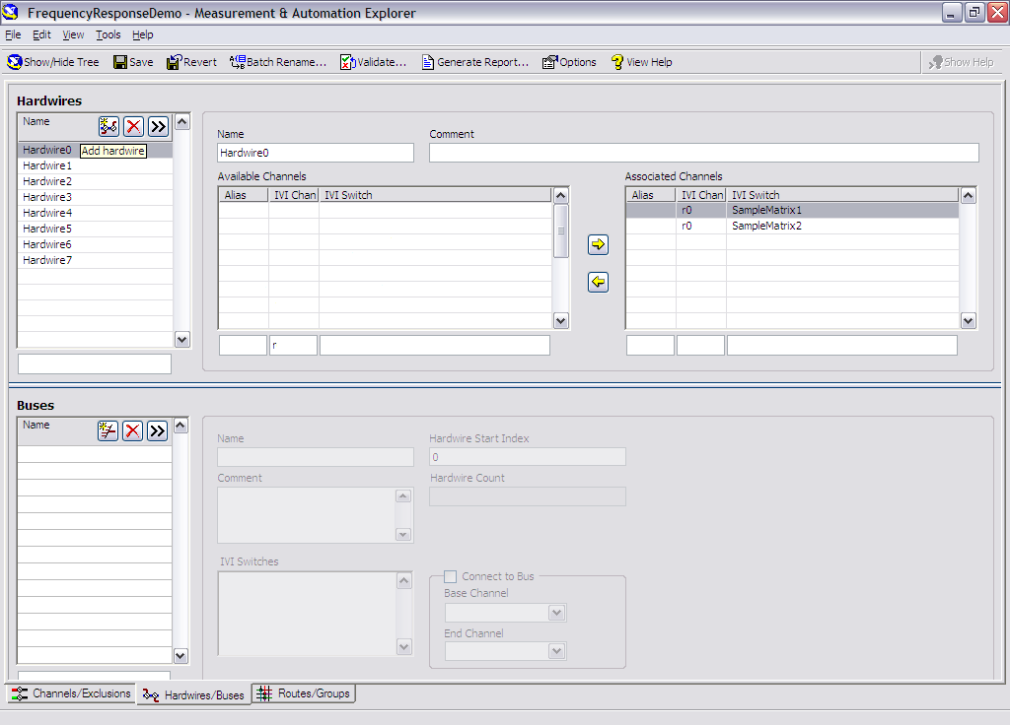

Figure 5

10) Select the Routes/Groups tab and create the following routes. To create a route, click the Create Route button and give the route an appropriate descriptive name. Then, select the channels for each endpoint of the route as shown in Figure 6. If the route is valid, NISE automatically creates it and reports at the bottom of the screen that the route configuration is valid.

Route | Endpoint 1 | Endpoint 2
PowerUUT1 | DC_Power | UUT1_Vcc
MeasSourceVoltage1 | DMM | UUT1_Vcc
SourceToInput1 | Source | UUT1_In
ScopeToOutput1 | Scope | UUT1_Out
PowerUUT2 | DC_Power | UUT2_Vcc
MeasSourceVoltage2 | DMM | UUT2_Vcc
SourceToInput2 | Source | UUT2_In
ScopeToOutput2 | Scope | UUT2_Out

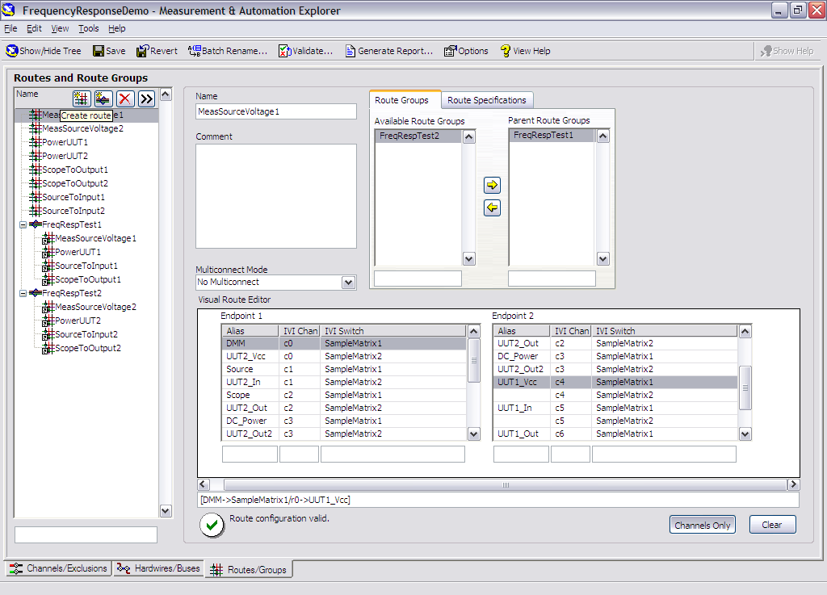

Figure 6

11) Create route groups that correspond to each of the 2 UUT’s. To create a route group, click the Create Route Group button, immediately to the right of the Create Route button. Name the Route Group FreqRespTest1 and add all of the routes ending with the number 1 to this group. This group will configure all of the connections that need to be made simultaneously when we run the test on the first UUT. When adding routes to the group, you may get an error message similar to the one in Figure 7.

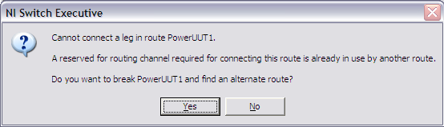

Figure 7

NISE has found that the route you are attempting to add to the group is using the same “Reserved For Routing” channel as another route in the group. Click Yes to allow Switch Executive to use a different “Reserved For Routing” channel.

12) Create another Route Group for the second UUT. Name it FreqRespTest2 and add all of the routes ending with the number 2 to this group just as you did for the first route group in the previous instruction. When you are done the routes should look similar to the tree on the left in Figure 8.

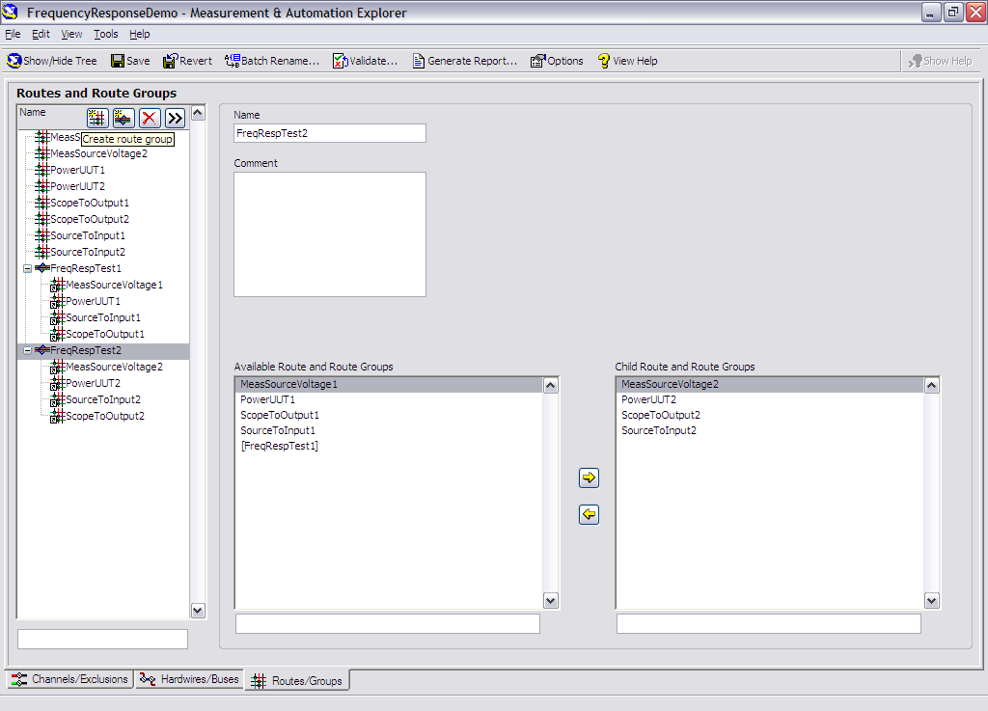

Figure 8

13) Click on the Validate button to confirm your configuration. Do not select the Use Simulation Mode option, as it is already specified in the IVI driver session. A connection will not be made on the hardware. NISE checks all of the connections and verifies that the channels are connected as configured and that there are no conflicts.

14) (Optional) Click on the Generate Report button to create an HTML report of your validation.

15) (Optional) Click on the Show/Hide Tree button and then right click on the Frequency Response Demo listing under the MAX tree on the left and then click on the Export selection to export your completed configuration to an XML file. This file can then be deployed to a new computer by being imported as a new NISE device. Select the Import Configuration From File selection instead of Create New Configuration when the virtual instrument is created.

16) LabVIEW Integration
a) Open Frequency Response Test Without NISE.vi from the Switch Executive Demo.zip file. NOTE: This VI will not run. Without NI Switch Executive you would have to open sessions to two different devices and then explicitly connect each row and column and then reconnect for any subsequent tests, which is very tedious and can easily become confusing.

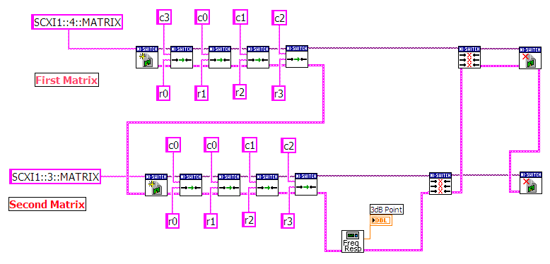
Figure 9

b) Now open Frequency Response Test With NISE.vi, also in Switch Executive Demo.zip. Verify that the Virtual Device Name and Route Specification match the ones you created in the demo. Look at the block diagram. Notice that only the single connect call is needed to connect the entire route group on the virtual device. Run the VI. A frequency response test will run that simulates finding the frequency response of a UUT using the switching configuration we created in Switch Executive.

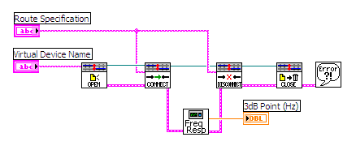
Figure 10

Conclusion
NI Switch Executive is a configuration tool designed to simplify switching systems. With NI Switch Executive you can do the following:
- Develop multiple device switch systems represented as a single virtual device
- Create end-to-end signal routing
- Route selections based on signal characteristics and switch capabilities
- Create route groups used to make intelligent resource selections when creating routes.
- Create switch routing for end-to-end calibration and maximum execution speed
- Create aliases for channels
- Preconfigured routes and route groups that can be called by name at run time
- Control NI and IVI-compliant third-party switches
- Generate a report of your switching system

